Lab 17: Data Import/Export and Backup
pgAdmin steps run in the Query Tool connected to the postgres database. Terminal steps run in the Mac Terminal app; keep the same Terminal window open for the whole lab.

Part 1. Setup

Step 1. Create a schema and the tables (pgAdmin)
DROP SCHEMA IF EXISTS lab17 CASCADE;
CREATE SCHEMA lab17;
SET search_path TO lab17;
CREATE TABLE employees (
employee_id SERIAL PRIMARY KEY,
first_name VARCHAR(50),
last_name VARCHAR(50),
email VARCHAR(100),
department VARCHAR(50)
);
CREATE TABLE products (
product_id SERIAL PRIMARY KEY,
name VARCHAR(50),
price DECIMAL(10,2)
);
CREATE TABLE customers (
customer_id SERIAL PRIMARY KEY,
name VARCHAR(100),
email VARCHAR(100),
city VARCHAR(50)
);
CREATE TABLE orders (
order_id SERIAL PRIMARY KEY,
customer_id INTEGER REFERENCES customers(customer_id),
order_date DATE,
amount DECIMAL(10,2)
);
CREATE TABLE customer_feedback (
feedback_id SERIAL PRIMARY KEY,
customer_name VARCHAR(50),
comment TEXT
);
CREATE TABLE sales_data (
sale_id SERIAL PRIMARY KEY,
region VARCHAR(50),
amount INTEGER
);

Step 2. Insert sample data (pgAdmin)
INSERT INTO employees (first_name, last_name, email, department) VALUES
('Aibek', 'Sharshenov', 'aibek@gmail.com', 'IT'),
('Ainura', 'Toktomamatova', 'ainura@gmail.com', 'Sales'),
('Bakyt', 'Mamatov', NULL, 'IT'),
('Gulzat', 'Sultanova', 'gulzat@mail.ru', 'HR');
INSERT INTO products (name, price) VALUES
('Laptop', 1200.00), ('Phone', 800.00), ('Headphones', 150.00);
INSERT INTO customers (name, email, city) VALUES
('Aibek Sharshenov', 'aibek@gmail.com', 'Bishkek'),
('Ainura Toktomamatova', 'ainura@gmail.com', 'Osh'),
('Bakyt Mamatov', 'bakyt@company.kg', 'Karakol');
INSERT INTO orders (customer_id, order_date, amount) VALUES
(1, '2024-01-15', 250.00), (2, '2024-03-02', 120.00), (1, '2024-05-20', 90.00);
INSERT INTO customer_feedback (customer_name, comment) VALUES
('Aibek', 'Great service, fast delivery'),
('Ainura', 'She said "wow" when it arrived');
SELECT * FROM employees;
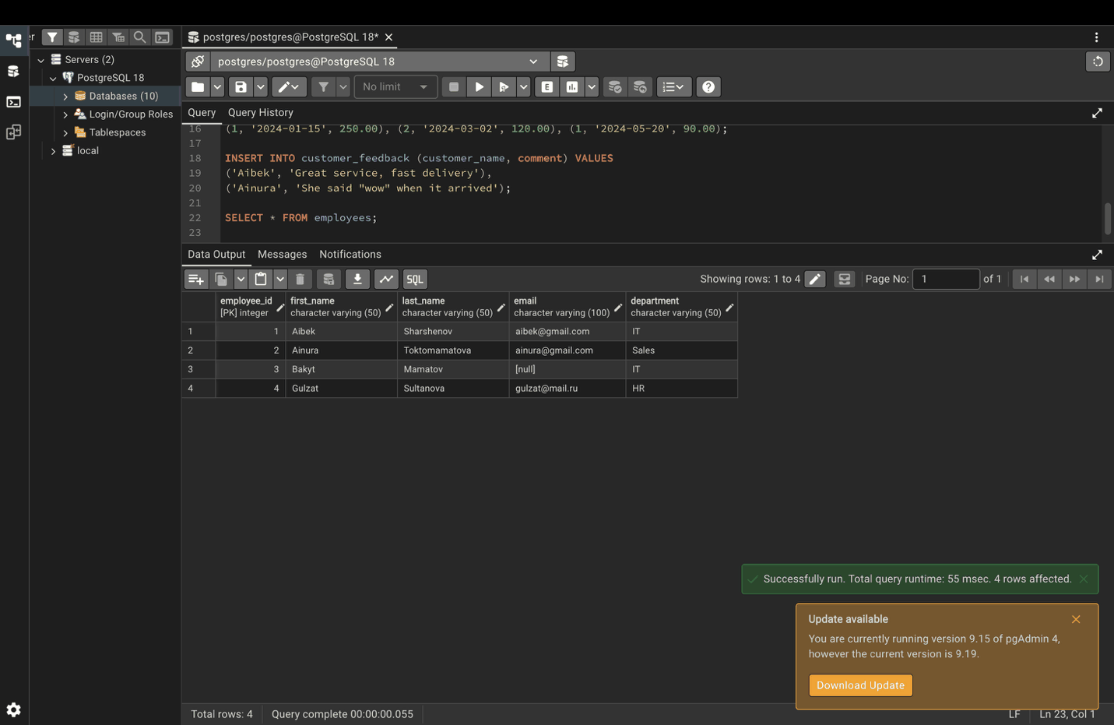

Part 2. COPY command

Step 3. Export a table to CSV
COPY employees TO '/tmp/employees.csv' WITH CSV HEADER;
In Mac Terminal:
cat /tmp/employees.csv
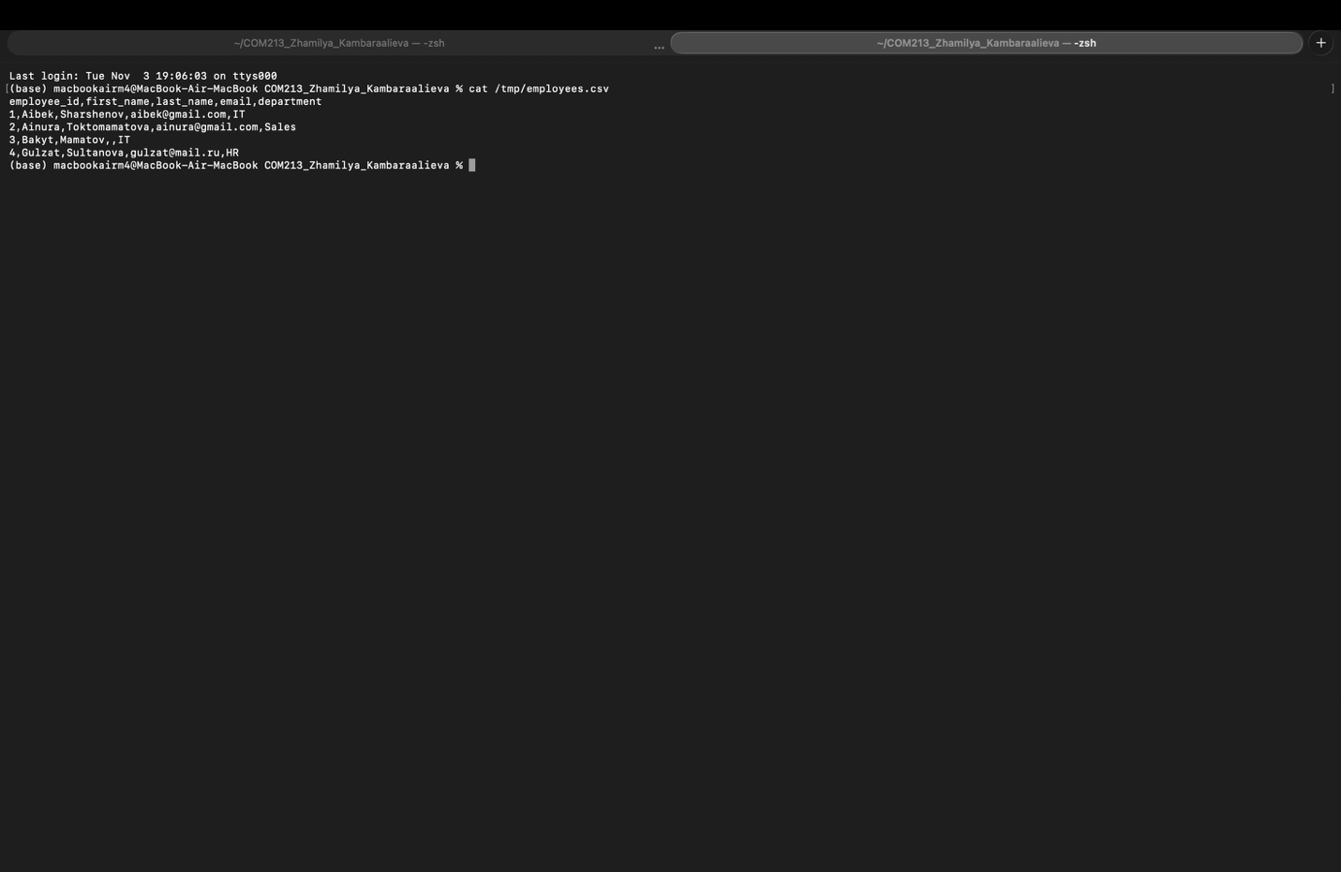

Step 4. Custom delimiter and NULL representation
COPY employees TO '/tmp/employees.txt'
WITH DELIMITER '|' NULL 'N/A' CSV HEADER;
In Mac Terminal: Bakyt has no email, so it shows N/A.
cat /tmp/employees.txt

Step 5. Export query results
COPY (SELECT * FROM employees WHERE department = 'IT')
TO '/tmp/it_employees.csv' WITH CSV HEADER;
In Mac Terminal:
cat /tmp/it_employees.csv

Step 6. Import specific columns only
In Mac Terminal: create the file first.
cat > /tmp/new_employees.csv << 'EOF'
first_name,last_name,email
Meerim,Bekova,meerim@gmail.com
Tilek,Usubaliev,tilek@mail.ru
EOF
Then in pgAdmin. The new employees have no department, because that column was not imported.
COPY employees(first_name, last_name, email)
FROM '/tmp/new_employees.csv' WITH CSV HEADER;
SELECT * FROM employees ORDER BY employee_id;
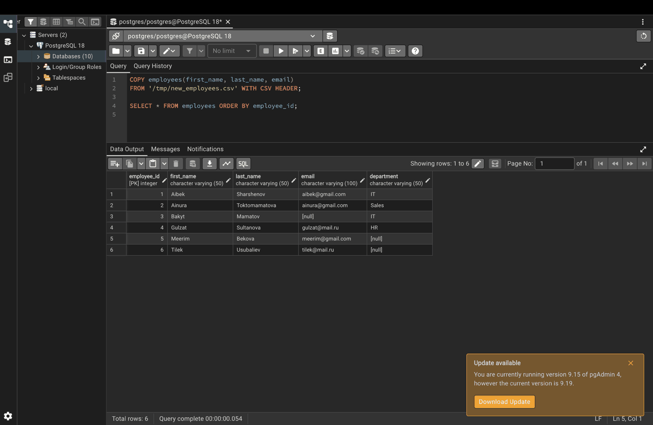

Part 3. CSV import/export

Step 7. Basic CSV export and import
The table is exported, emptied, and then loaded back from the file.
COPY products TO '/tmp/products.csv' WITH CSV HEADER;
TRUNCATE products; -- empty the table
COPY products FROM '/tmp/products.csv' WITH CSV HEADER;
SELECT * FROM products ORDER BY product_id;
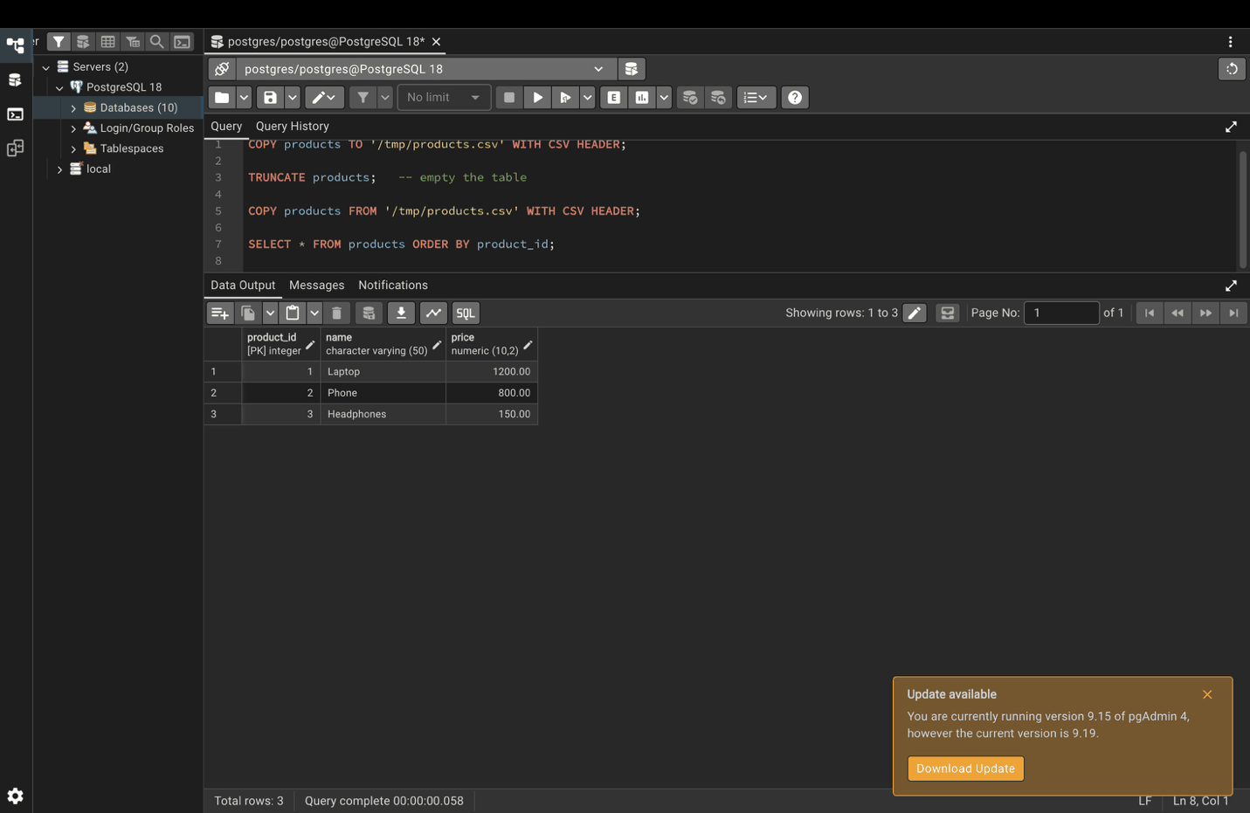

Step 8. Custom delimiter and quote character
COPY customers TO '/tmp/customers.csv'
WITH CSV HEADER DELIMITER ';' QUOTE '"';
In Mac Terminal:
cat /tmp/customers.csv

Step 9. Force quotes on a column
The handout version (WITH CSV HEADER FORCE_QUOTE (order_date)) gives a syntax error, because FORCE_QUOTE with parentheses only works inside the WITH ( ... ) option list.
COPY orders TO '/tmp/orders.csv'
WITH (FORMAT csv, HEADER, FORCE_QUOTE (order_date));
In Mac Terminal: Every order_date is wrapped in quotes.
cat /tmp/orders.csv

Step 10. Skip bad rows with ON_ERROR IGNORE
In Mac Terminal: the Mouse row has an invalid price.
cat > /tmp/products_with_errors.csv << 'EOF'
name,price
Keyboard,80
Mouse,abc
Monitor,300
EOF
Then in pgAdmin. Keyboard and Monitor are imported, the Mouse row is skipped (ON_ERROR needs PostgreSQL 17 or newer).
COPY products(name, price) FROM '/tmp/products_with_errors.csv'
WITH (FORMAT csv, HEADER, ON_ERROR ignore);
SELECT * FROM products ORDER BY product_id;
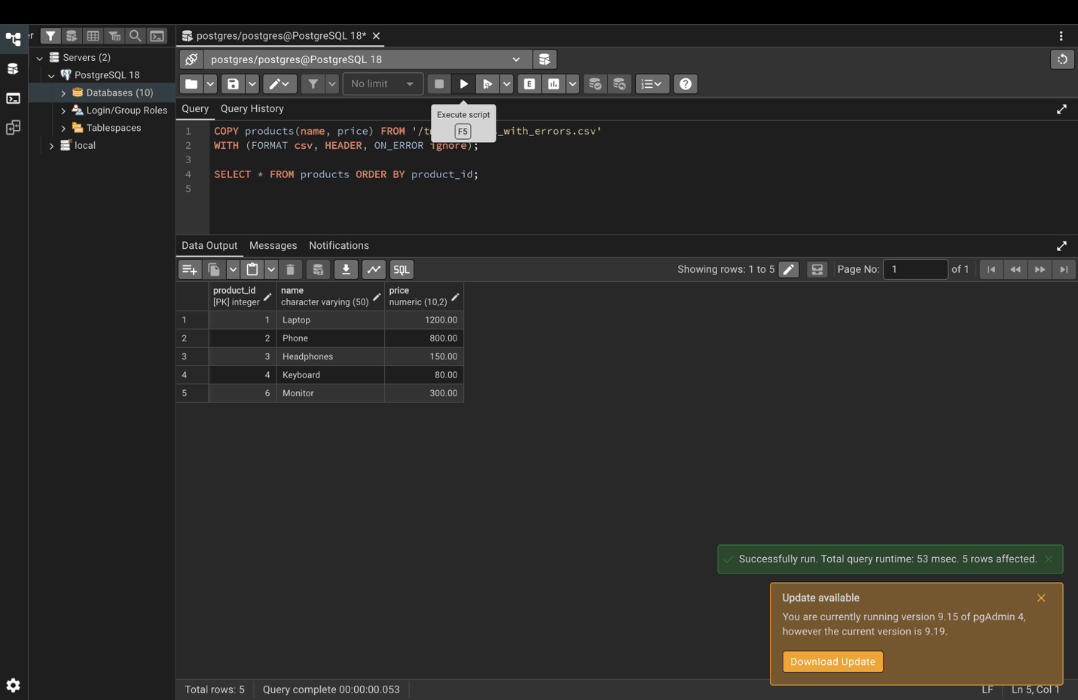

Step 11. Import with a specific encoding
In Mac Terminal:
cat > /tmp/products_utf8.csv << 'EOF'
name,price
Ноутбук,1100
Наушники,140
EOF
Then in pgAdmin. The Cyrillic names are read correctly.
COPY products(name, price) FROM '/tmp/products_utf8.csv'
WITH CSV HEADER ENCODING 'UTF8';
SELECT * FROM products ORDER BY product_id;

Step 12. Embedded commas and quotes
COPY customer_feedback TO '/tmp/feedback.csv'
WITH CSV HEADER DELIMITER ',' QUOTE '"' ESCAPE '"';
In Mac Terminal: The comment with a comma is quoted, and the inner quotes are doubled.
cat /tmp/feedback.csv

Step 13. Custom NULL representation
In Mac Terminal:
cat > /tmp/sales.csv << 'EOF'
region,amount
Bishkek,500
Osh,NULL
Karakol,300
EOF
Then in pgAdmin. The text NULL is loaded as a real NULL value.
COPY sales_data(region, amount) FROM '/tmp/sales.csv'
WITH CSV HEADER NULL 'NULL';
SELECT * FROM sales_data;

Part 4. pg_dump and pg_restore

Step 14. Prepare Terminal
In Mac Terminal: replace your_password with your pgAdmin password, so you are not asked for it every time. The backups are saved in a pg_backups folder in your home folder.
export PATH="/Library/PostgreSQL/18/bin:$PATH"
export PGPASSWORD='your_password'
mkdir -p ~/pg_backups
pg_dump --version

Step 15. Plain SQL backup
In Mac Terminal: -n lab17 backs up only this lab's schema instead of the whole postgres database.
pg_dump -h localhost -U postgres -d postgres -n lab17 > ~/pg_backups/lab17_backup.sql
head -40 ~/pg_backups/lab17_backup.sql

Step 16. Compressed custom-format backup with verbose output
In Mac Terminal:
pg_dump -h localhost -U postgres -d postgres -n lab17 -Fc -v > ~/pg_backups/lab17_backup.dump
ls -lh ~/pg_backups
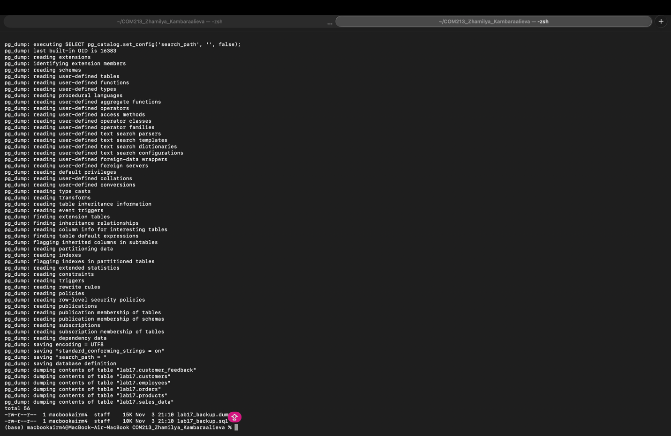

Step 17. Back up specific tables only
In Mac Terminal:
pg_dump -h localhost -U postgres -d postgres -t lab17.employees -t lab17.products > ~/pg_backups/tables_backup.sql
grep "CREATE TABLE" ~/pg_backups/tables_backup.sql

Step 18. Schema-only and data-only backups
In Mac Terminal: The schema-only file has the CREATE TABLE commands; the data-only file has none.
pg_dump -h localhost -U postgres -d postgres -n lab17 -s > ~/pg_backups/schema_only.sql
pg_dump -h localhost -U postgres -d postgres -n lab17 -a > ~/pg_backups/data_only.sql
grep -c "CREATE TABLE" ~/pg_backups/schema_only.sql ~/pg_backups/data_only.sql

Step 19. Exclude specific tables
In Mac Terminal: customer_feedback and sales_data are not in the list.
pg_dump -h localhost -U postgres -d postgres -n lab17 -T lab17.customer_feedback -T lab17.sales_data > ~/pg_backups/backup_without_logs.sql
grep "CREATE TABLE" ~/pg_backups/backup_without_logs.sql

Step 20. Validate the backup
In Mac Terminal: This lists what the backup contains without restoring anything.
pg_restore --list ~/pg_backups/lab17_backup.dump | head -30

Step 21. Restore to a new database (parallel jobs)
In Mac Terminal:
createdb -h localhost -U postgres lab17_restore
pg_restore -h localhost -U postgres -d lab17_restore -j 4 ~/pg_backups/lab17_backup.dump
psql -h localhost -U postgres -d lab17_restore -c "SELECT * FROM lab17.employees;"
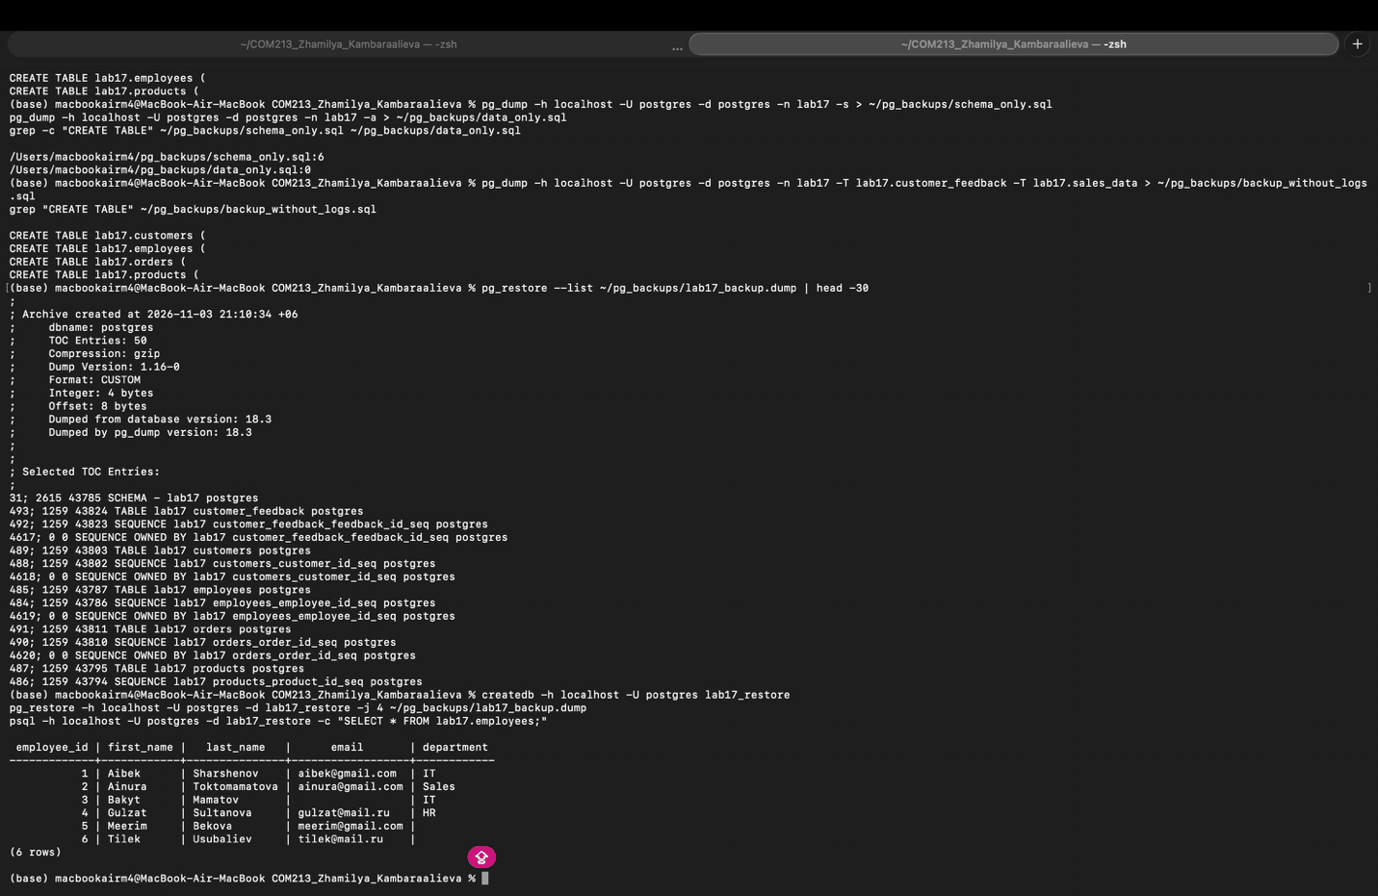

Step 22. Restore a specific table only
In Mac Terminal: Only the employees table is restored.
createdb -h localhost -U postgres lab17_partial
psql -h localhost -U postgres -d lab17_partial -c "CREATE SCHEMA lab17;"
pg_restore -h localhost -U postgres -d lab17_partial -n lab17 -t employees ~/pg_backups/lab17_backup.dump
psql -h localhost -U postgres -d lab17_partial -c "\dt lab17.*"

Part 5. Full database backups

Step 23. Back up the whole server with pg_dumpall
In Mac Terminal: pg_dumpall backs up every database on the server. -s (structure only) keeps the file small; without it the data is included too.
pg_dumpall -h localhost -U postgres -s > ~/pg_backups/full_cluster_backup.sql
grep "CREATE DATABASE" ~/pg_backups/full_cluster_backup.sql

Step 24. Full backup of a single database
In Mac Terminal:
pg_dump -h localhost -U postgres -d lab17_restore -Fc --verbose > ~/pg_backups/full_lab17_backup.dump
ls -lh ~/pg_backups/full_lab17_backup.dump

Step 25. Automated backup script
In Mac Terminal: The script creates a backup file with the date and time in its name.
cat > ~/pg_backups/backup.sh << 'EOF'
#!/bin/bash
# Daily backup script
DATE=$(date +%Y%m%d_%H%M%S)
BACKUP_DIR="$HOME/pg_backups"
DB_NAME="lab17_restore"
pg_dump -h localhost -U postgres -d $DB_NAME -Fc > "$BACKUP_DIR/${DB_NAME}_${DATE}.dump"
# Keep only last 7 days of backups
find $BACKUP_DIR -name "${DB_NAME}_*.dump" -mtime +7 -delete
EOF
chmod +x ~/pg_backups/backup.sh
~/pg_backups/backup.sh
ls -lh ~/pg_backups/*.dump
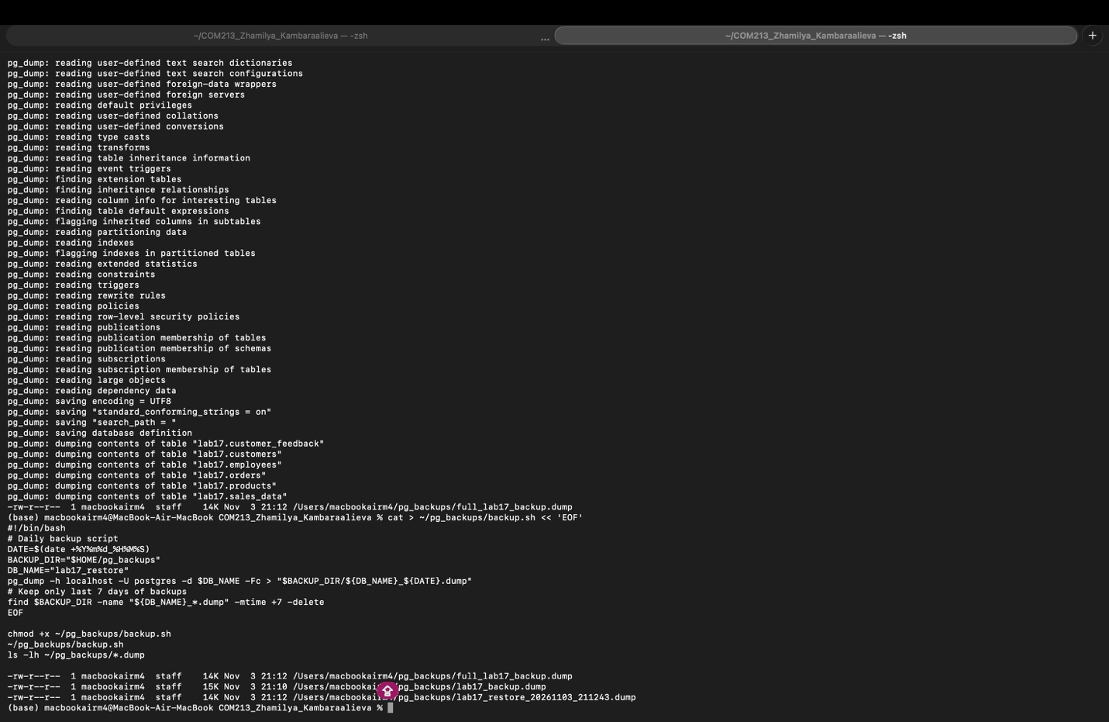

Part 6. Incremental backups and Point-in-Time Recovery

Step 26. Check the WAL settings (pgAdmin)
wal_level = replica is needed for incremental backups and PITR. Turning on archive_mode requires editing postgresql.conf and restarting the server, so it is only checked here.
SELECT name, setting
FROM pg_settings
WHERE name IN ('wal_level', 'archive_mode', 'archive_command', 'max_wal_senders');

Step 27. Switch the WAL file and create a restore point (pgAdmin)
A restore point is a named moment that PITR can later recover to (recovery_target_name).
SELECT
pg_switch_wal() AS wal_switch,
pg_create_restore_point('before_data_migration') AS restore_point;
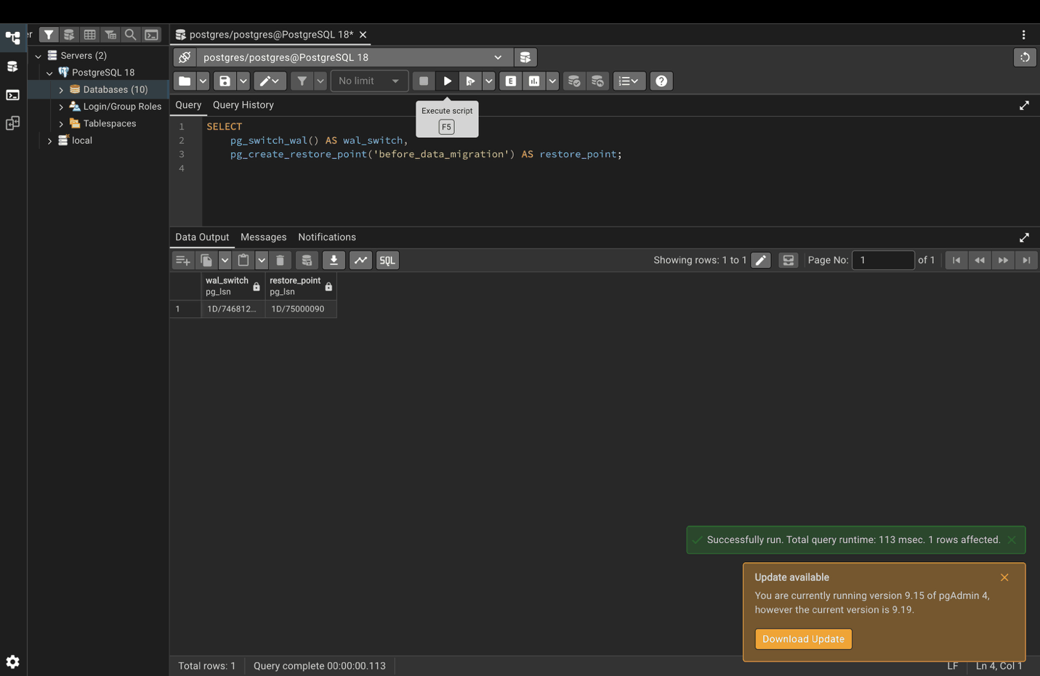

Step 28. Create a base backup with pg_basebackup
In Mac Terminal: This copies the whole server (all databases), so it can take a minute and needs free disk space about the size of your databases. -c fast starts the backup immediately instead of waiting for the next checkpoint. WAL files are included by default (the old -x option was replaced by -X stream).
pg_basebackup -h localhost -U postgres -D ~/pg_backups/base -Ft -z -P -c fast
ls -lh ~/pg_backups/base
Point-in-Time Recovery is not performed in this lab, because it requires stopping the server and deleting its data directory. The process is: stop PostgreSQL, replace the data directory with the base backup from Step 28, add restore_command and recovery_target_name = 'before_data_migration' to postgresql.conf, create an empty recovery.signal file, and start PostgreSQL. The server then replays the archived WAL files up to the restore point created in Step 27.

Part 7. Data migration strategies
Strategy 1 (dump and restore) was done in Steps 16 and 21.

Step 29. Strategy 2: logical replication publication (pgAdmin)
The publication is created on the source. The CREATE SUBSCRIPTION part needs a second server and wal_level = logical, so it is not run here.
CREATE PUBLICATION migration_pub FOR TABLE lab17.customers, lab17.orders;
SELECT * FROM pg_publication_tables WHERE pubname = 'migration_pub';

Step 30. Strategy 4: ETL pipeline (pgAdmin)
Customer 1 already existed as "Old Name", so it is updated; customers 2 and 3 are inserted.
-- Create a staging table and a target table
CREATE TABLE staging_customers AS SELECT * FROM customers WHERE 1=0;
CREATE TABLE target_customers (LIKE customers INCLUDING ALL);
INSERT INTO target_customers VALUES (1, 'Old Name', 'old@mail.com', 'Bishkek');
-- Extract data in batches
COPY (SELECT * FROM customers LIMIT 10000 OFFSET 0)
TO '/tmp/customers_batch_1.csv' WITH CSV HEADER;
-- Load into staging
COPY staging_customers FROM '/tmp/customers_batch_1.csv' WITH CSV HEADER;
-- Validate and merge
INSERT INTO target_customers
SELECT * FROM staging_customers
ON CONFLICT (customer_id) DO UPDATE
SET name = EXCLUDED.name, email = EXCLUDED.email, city = EXCLUDED.city;
SELECT * FROM target_customers ORDER BY customer_id;
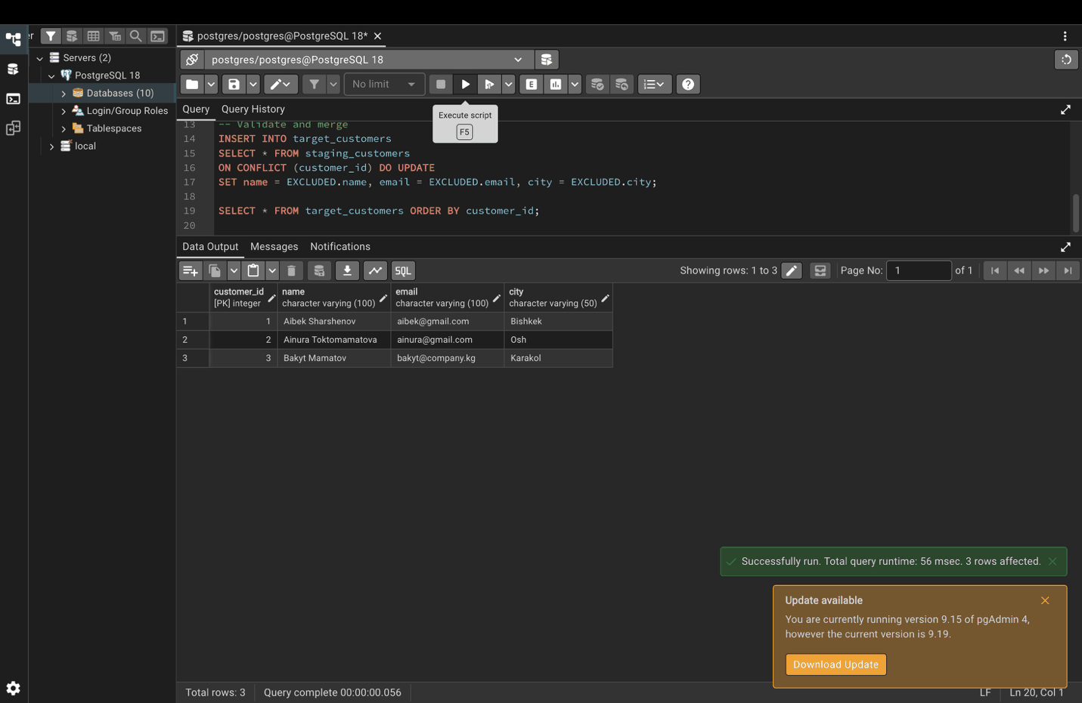

Step 31. Migration with validation (row counts)
In Mac Terminal: The table is copied to a new database, and both counts must match.
createdb -h localhost -U postgres lab17_target
psql -h localhost -U postgres -d lab17_target -c "CREATE SCHEMA lab17;"
pg_dump -h localhost -U postgres -d postgres -t lab17.customers | psql -h localhost -U postgres -d lab17_target
psql -h localhost -U postgres -d postgres -c "SELECT COUNT(*) AS source_count FROM lab17.customers;"
psql -h localhost -U postgres -d lab17_target -c "SELECT COUNT(*) AS target_count FROM lab17.customers;"
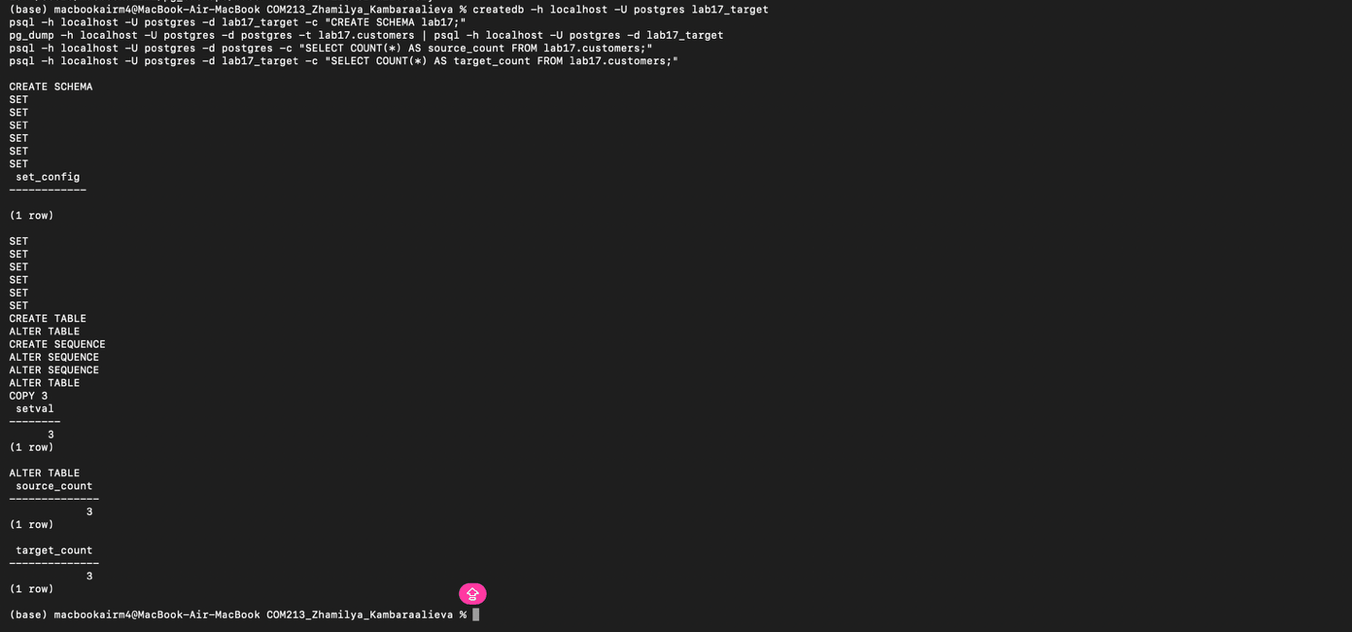

Step 32. Partition a large table (pgAdmin)
CREATE TABLE large_table (
sale_id INTEGER,
sale_date DATE,
amount INTEGER
) PARTITION BY RANGE (sale_date);
CREATE TABLE large_table_2023 PARTITION OF large_table
FOR VALUES FROM ('2023-01-01') TO ('2024-01-01');
CREATE TABLE large_table_2024 PARTITION OF large_table
FOR VALUES FROM ('2024-01-01') TO ('2025-01-01');
INSERT INTO large_table VALUES
(1, '2023-03-10', 500), (2, '2023-11-25', 700),
(3, '2024-02-14', 300), (4, '2024-08-01', 900);
SELECT tableoid::regclass AS partition, * FROM large_table;

Step 33. Migrate one partition
In Mac Terminal: Only the 2023 rows are exported, so each partition can be migrated separately.
pg_dump -h localhost -U postgres -d postgres -t lab17.large_table_2023 -a --inserts | grep INSERT

